

**A 12**

**Sreenidhi Institute of Science & Technology**

(An Autonomous Institution)

**Code No: 121EE01**

**B. TECH. I – Year II – Semester Examinations, July, 2014 (Regular)**

**Circuits & Networks - I (EEE)**

**Time: 3 Hours Max. Marks: 70**

**Note: No additional answer sheets will be provided.**

**Part-A**

**Max.Marks:20**

**Answer all QUESTIONS.**

**1.** What are Active and Passive elements?

2. Define Tie set and Cut set Matrix.

3. Compare Electric and Magnetic circuits.

4. Define RMS & Average value.

5. What is Complex power expression?

6. What is the significance of Locus Diagrams?

7. Define Maximum Power Transfer theorem.

8. Define Circuit and Network.

9. Draw the duality network for RLC series network with ac source.

10. What are Network Reduction techniques?

**Part – B**

**Max. Marks: 50**

**ANSWER ANY FIVE QUESTIONS. EACH QUESTION CARRIES 10 MARKS.**

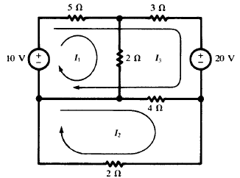 **1.** Loop currents are shown in the network of Fig. Write the matrix equation and solve for the three currents.

**2.** For the following graph find No of i) trees ii)links iii)twigs iv) tree branches v)nodes

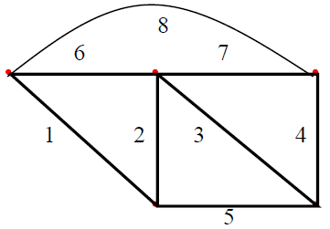

**3.** For the three coupled coils in Fig, calculate the total inductance.

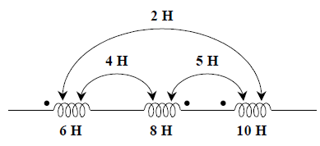

**4.** Use current division twice to find **I** for the circuit shown in Fig.

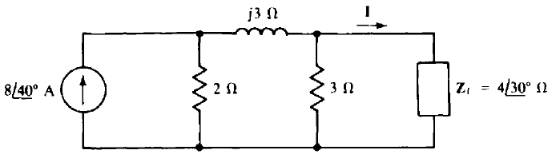

**5.** Find the value of Rx so that power dissipated in it is maximum.

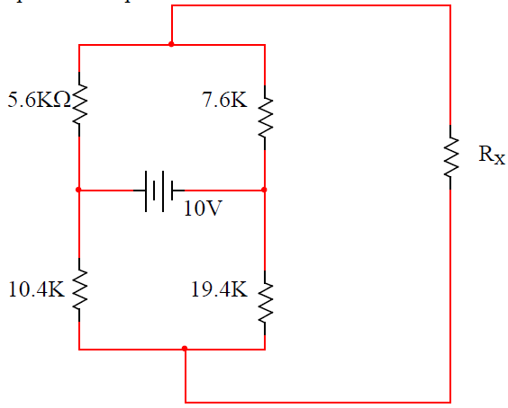

**6.** Draw and explain **the Y-locus when R is ﬁxed and L or ω is variable.**

**7.** Define the following:

i)Average Value ii)Reactive power iii)Power Factor iv)Admittance

v)Band width vi)Q factor

**8.** Find Zth and Vth and **I,** for the Thevenin and Norton equivalents of the circuit shown in Fig.

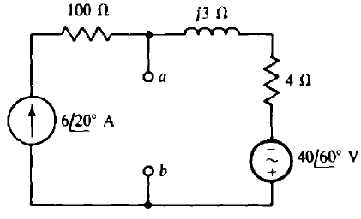

**-- 00 -- 00 --**